Additional constraints in NNF and PNF in parameter search

1. 0L8

2. 0M8

(Figure out why PNF has the largest oscillatory region)

3. 1M8 (how to Compare PNF and NNF )

New constraints:

1. max(Ptot) match SNF

2. relative amp of Ptot > 0.5

3. Period of Ptot

SNF 1M8

Kd=1, Vmax=5, Km=5.5, KA=20.

AT=20, alpha=50

Period = 27, max(Ptot)=75

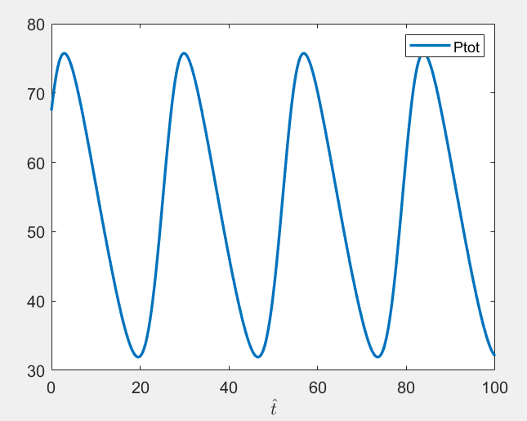

NNF 1M8

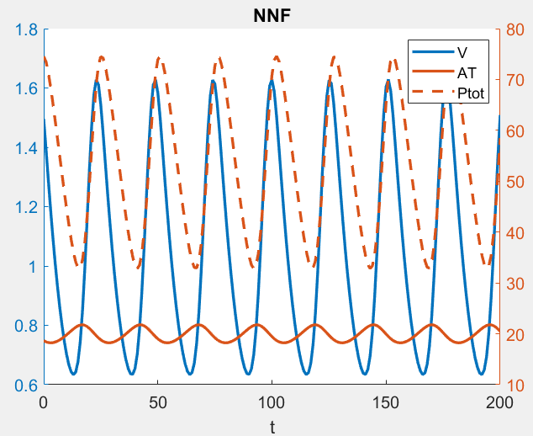

delta = 0.1, Amax=40, Vmax=13

avg(At)~20, amp(At)~0.25

max(Ptot) ~75, amp(Ptot)~0.4, period(Ptot)~27

PNF 1M8

delta = 0.09, Amax=55.4, Rmax=7.3

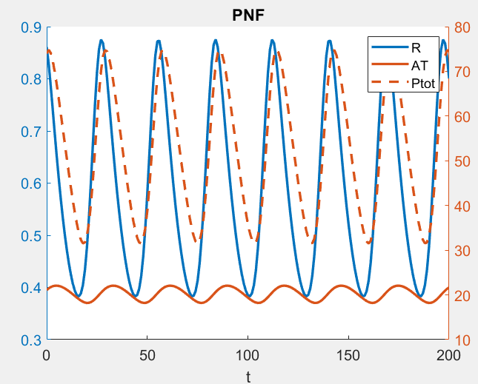

Overlay of the main characteristics of the core loop

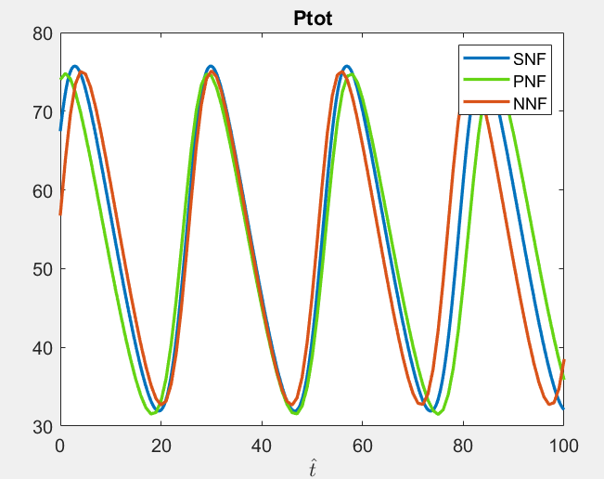

Summary of parameters for 1M8 models

|  |  |  |  |
| --- | --- | --- | --- |
|  | SNF | NNF | PNF |
| Kd | 1 | 1 | 1 |
| Vmax (MM) | 5 | 5 | 5 |
| Km | 5.5 | 5.5 | 5.5 |
| Ka | 20 | 20 | 20 |
| At0 | 20 |  |  |
| Alpha | 50 | 50 | 50 |
| Delta |  | 0.1 | 0.09 |
| Amax |  | 40 | 55.4 |
| Vmax |  | 13 |  |
| Rmax |  |  | 7.3 |

1M8 Amax-alpha bifurcation

